**CME227 DATA STRUCTURES**

**Make-up, January, 20, 2014**

**Number/Name/Division:........................................................ Duration: 75 minutes**

1-) (15 pts.) Circle T or F for each of the following statements to indicate whether the statement is **true** or **false**, respectively. If the statement is wrong, explain why.

* **T F** The height of any binary search tree with n nodes is at most n-1
* **T F** Depth of a node in a tree is the number of edges on the path from the node to the deepest leaf
* **T F** Recursive function calls use stack
* **T F** A binary heap is also a BST.
* **T F** Every node in a binary tree has exactly 2 children.

2-) (20 pts.)You are given the following AVL tree.

a) Write the height of each node.

b) Insert 60 into the tree, and perform rotation(s)   
to make it an AVL tree. Write down the final tree.

3-) (20 pts.) What is the smallest and largest number of nodes in a heap of height 7? What is the height of a heap with 400 nodes?

4-) (25 pts.) Write a function that deletes the node with a given key value in a doubly linked-list. The function will take two parameters. Note that you should check all cases. Draw each case near the code block.

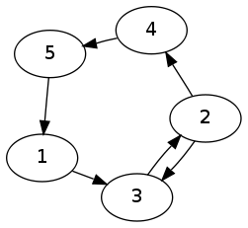

5-) (20 pts) What are the adjacency list and adjacency matrix   
representations of the following directed graph. Indicate which   
representation you would choose for this graph and why?

6-) (20 pts) Write a function SmallerThan(BTREE root, int x) that outputs, in ascending order of keys, all elements in a BST whose keys are smaller than or equal to x.

**GOOD LUCK**